Pixel Monarch Project Report

Virginia Tech
ECE 2564 - Fall 2025
Project 1: Pixel Monarch
Samin Rahman
GitHub Username: saminzr
Repository Link:
https://github.com/VT-ECE-2564-assignments/f25-proj1-saminzr.git
Date: 10/30/2025

Report Summary
This report documents the implementation of Pixel Monarch, a resource-management game developed for the MSP432 microcontroller. Pixel Monarch is an interactive, resource-management simulation that features multiple screens, UART-based input handling, finite state machines, and non-blocking code architecture. This report covers project description, system architecture diagram, code quality self-assessment and the implementation of additional bonus features.

Project Description
The objective of this project is to design, develop, and implement an interactive, resource-management simulation game called Pixel Monarch. The game tasks players with balancing People (PE), Treasury (TR), and Territory while responding to events that threaten the kingdom. The game incorporates Main Menu screen that allows players to navigate between Play Game, Instructions, and High Scores. The Game Screen displays resources, territory grid, and year counter. The game uses UART-based system for responding to events (Flood, Famine, Raid, Calm Period). The game ends with Game Over screen showing survival years with option to restart. The game allows for baud rate switching via LaunchPad button with visual LED feedback. All core requirements from the project specification have been implemented. The list for them as follows:
- Non-blocking code architecture
- UART communication at multiple baud rates
- Finite state machine for screen management
- Correct implementation of Main Menu, Game Screen, and Game over
- High score tracking
- Random event generation and territory management
- All four event types with appropriate resource deductions and territory changes.
- Territory grid with controlled (green) and lost (red) regions.

Figure 1, Main Menu:
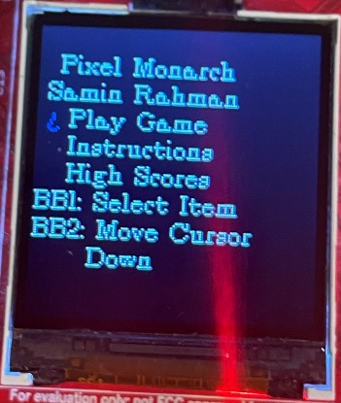
Figure 2, Game Screen:
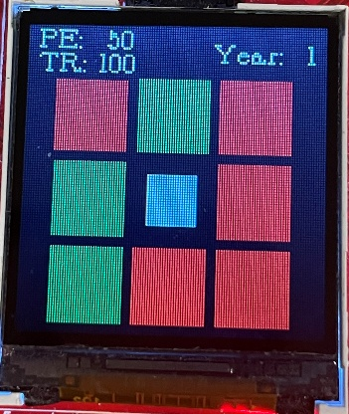
Figure 3, Game Over:
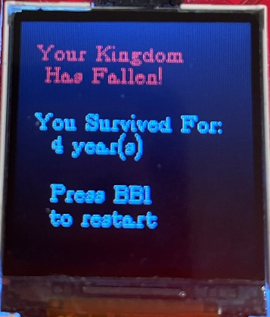

Microcontroller-Based Embedded System Architecture
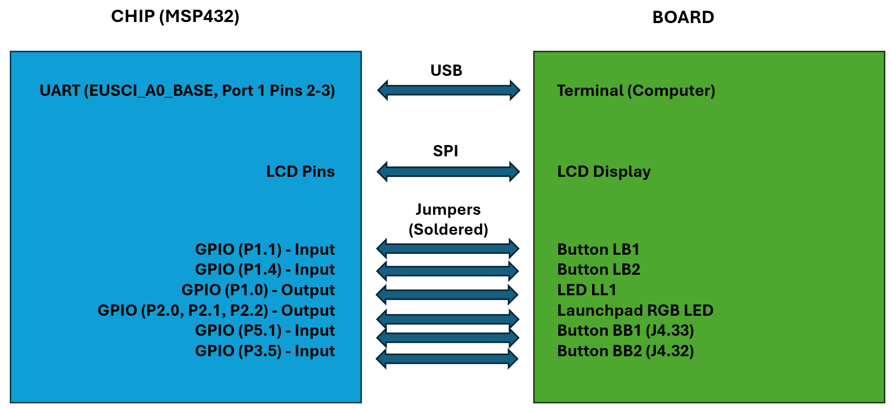
All peripherals in a microcontroller — such as GPIO, timers, ADCs, UART, SPI, and I²C — are ultimately controlled and accessed through pins on the chip. These pins are connected internally to the CPU and peripheral modules via a system bus that uses memory-mapped registers for configuration, data transfer, and status monitoring.
In a memory-mapped I/O architecture (used by most modern MCUs, including the MSP432), each peripheral register is assigned a specific address in the processor’s memory space. This allows the CPU to interact with hardware peripherals using the same load and store instructions used for normal memory operations.
- Input pins: When configured as inputs, the electrical signals on the physical pins are sampled by the hardware and stored in associated input registers. The CPU can then read these registers to determine the logic level or analog value currently present on the pins.
- Output pins: When configured as outputs, writing a value to the corresponding output register updates the logic level driven on the pin. Thus, software control of pin states is achieved by writing to these memory-mapped registers.
Each peripheral typically has multiple registers — for example, direction control (input/output), data input/output, interrupt enable/flag, and mode selection registers. Through these registers, firmware can configure and manipulate hardware behavior directly.
This design provides a unified interface between software and hardware:
- Peripherals behave like memory locations.
- The CPU can control and monitor external devices without requiring specialized I/O instructions.
In the MSP432 specifically, all peripheral modules (GPIO, Timer_A, ADC14, UART, etc.) are accessible through the AMBA bus and have fixed base addresses in the system memory map, as documented in the device’s technical reference manual. This memory-mapped I/O mechanism ensures deterministic and efficient communication between software and hardware.

Code Quality
The aspects are described in the table below. It was especially challenging to keep the functions within 50 lines, commenting the code, and keeping the architecture non-blocking throughout.
The code follows all specified quality requirements:
Code Quality Aspect | Maximum Points | Points Expected | Justification
Comments | 10 | 8 | Code is mostly commented, except some parts of large functions
Constants/Macros | 20 | 18 | Almost all numeric values (except 0/1 and small-array indices) are defined as macros
Function Length | 30 | 30 | No function greatly exceeds 50 lines (at most 55)
No Global Variables | 20 | 20 | All state stored in Application struct, and Graphics Context struct used for LCD display; no global variables used
Non-Blocking Code | 20 | 20 | LB1 immediately controls LL1 at any point during game execution
TOTAL | 100 | 96

Bonus Features
Bonus Feature | Maximum Points | Points Expected | Status
Custom Images | 25 | 0 | Not implemented
Backspace Support | 25 | 25 | Fully and properly implemented for all UART input stages
Variable Grid Size | 30 | 30 | User can choose a 3x3 or 5x5 grid.
Adjustable Resources | 30 | 30 | User can adjust the starting resources (PE and TR)
Progressive Difficulty | 50 | 50 | Resource costs increase by 5 across the board every 5 years
Joystick Support | 100 | 0 | Not implemented
Joystick Randomization | 50 | 0 | Not implemented
BONUS TOTAL | 150 | 135

